Ghana DPA Compliance for Log360
Strengthen data protection and meet Ghana DPA compliance with Log360.
Region: Ghana | Type: Data Privacy | Category: Compliance | Pricing: Free

Overview
The Ghana DPA compliance extension in Log360 helps organizations meet Ghana's Data Protection Act (Act 843), enacted by the Parliament of Ghana and enforced by the Data Protection Commission by providing centralized log management, real-time unauthorized access detection, and compliance-focused audit reporting. The platform supports Ghana DPA requirements for security safeguards, data loss prevention, continuous safeguard verification, processor oversight, breach notification, risk identification, data subject rights, data retention, and registration documentation across cloud and on-premise environments.
For Section 28 — Security Safeguards Against Unauthorized Access, Log360 monitors logon events, failed access attempts, and authentication across AD, Windows, and network devices to detect unauthorized data access. To address Section 28 — Security Safeguards Against Data Loss, the platform monitors file integrity, backup operations, system events, and data modifications to detect data loss incidents and verify protective safeguards. The extension also supports Section 28 — Continuous Safeguard Verification by providing capabilities that provides ongoing security monitoring, configuration auditing, and threat detection to continuously verify and update security safeguard effectiveness.

Key Features
- Section 30 — Processor Security Obligations: Log360 monitors processor access patterns, data handling events, and authentication to verify processor security compliance.
- Section 31 — Personal Data Breach Notification: Log360 provides real-time breach detection, alerting, and forensic analysis to identify breaches and support timely notification obligations.
- Section 28 — Risk Identification and Assessment: Log360 monitors threat indicators, vulnerability events, and security anomalies across all systems to support comprehensive risk identification for data protection programs.
- Sections 32-35 — Data Subject Access and Participation: Log360 monitors user account changes, data modifications, and access requests to provide audit evidence of data subject rights fulfillment.


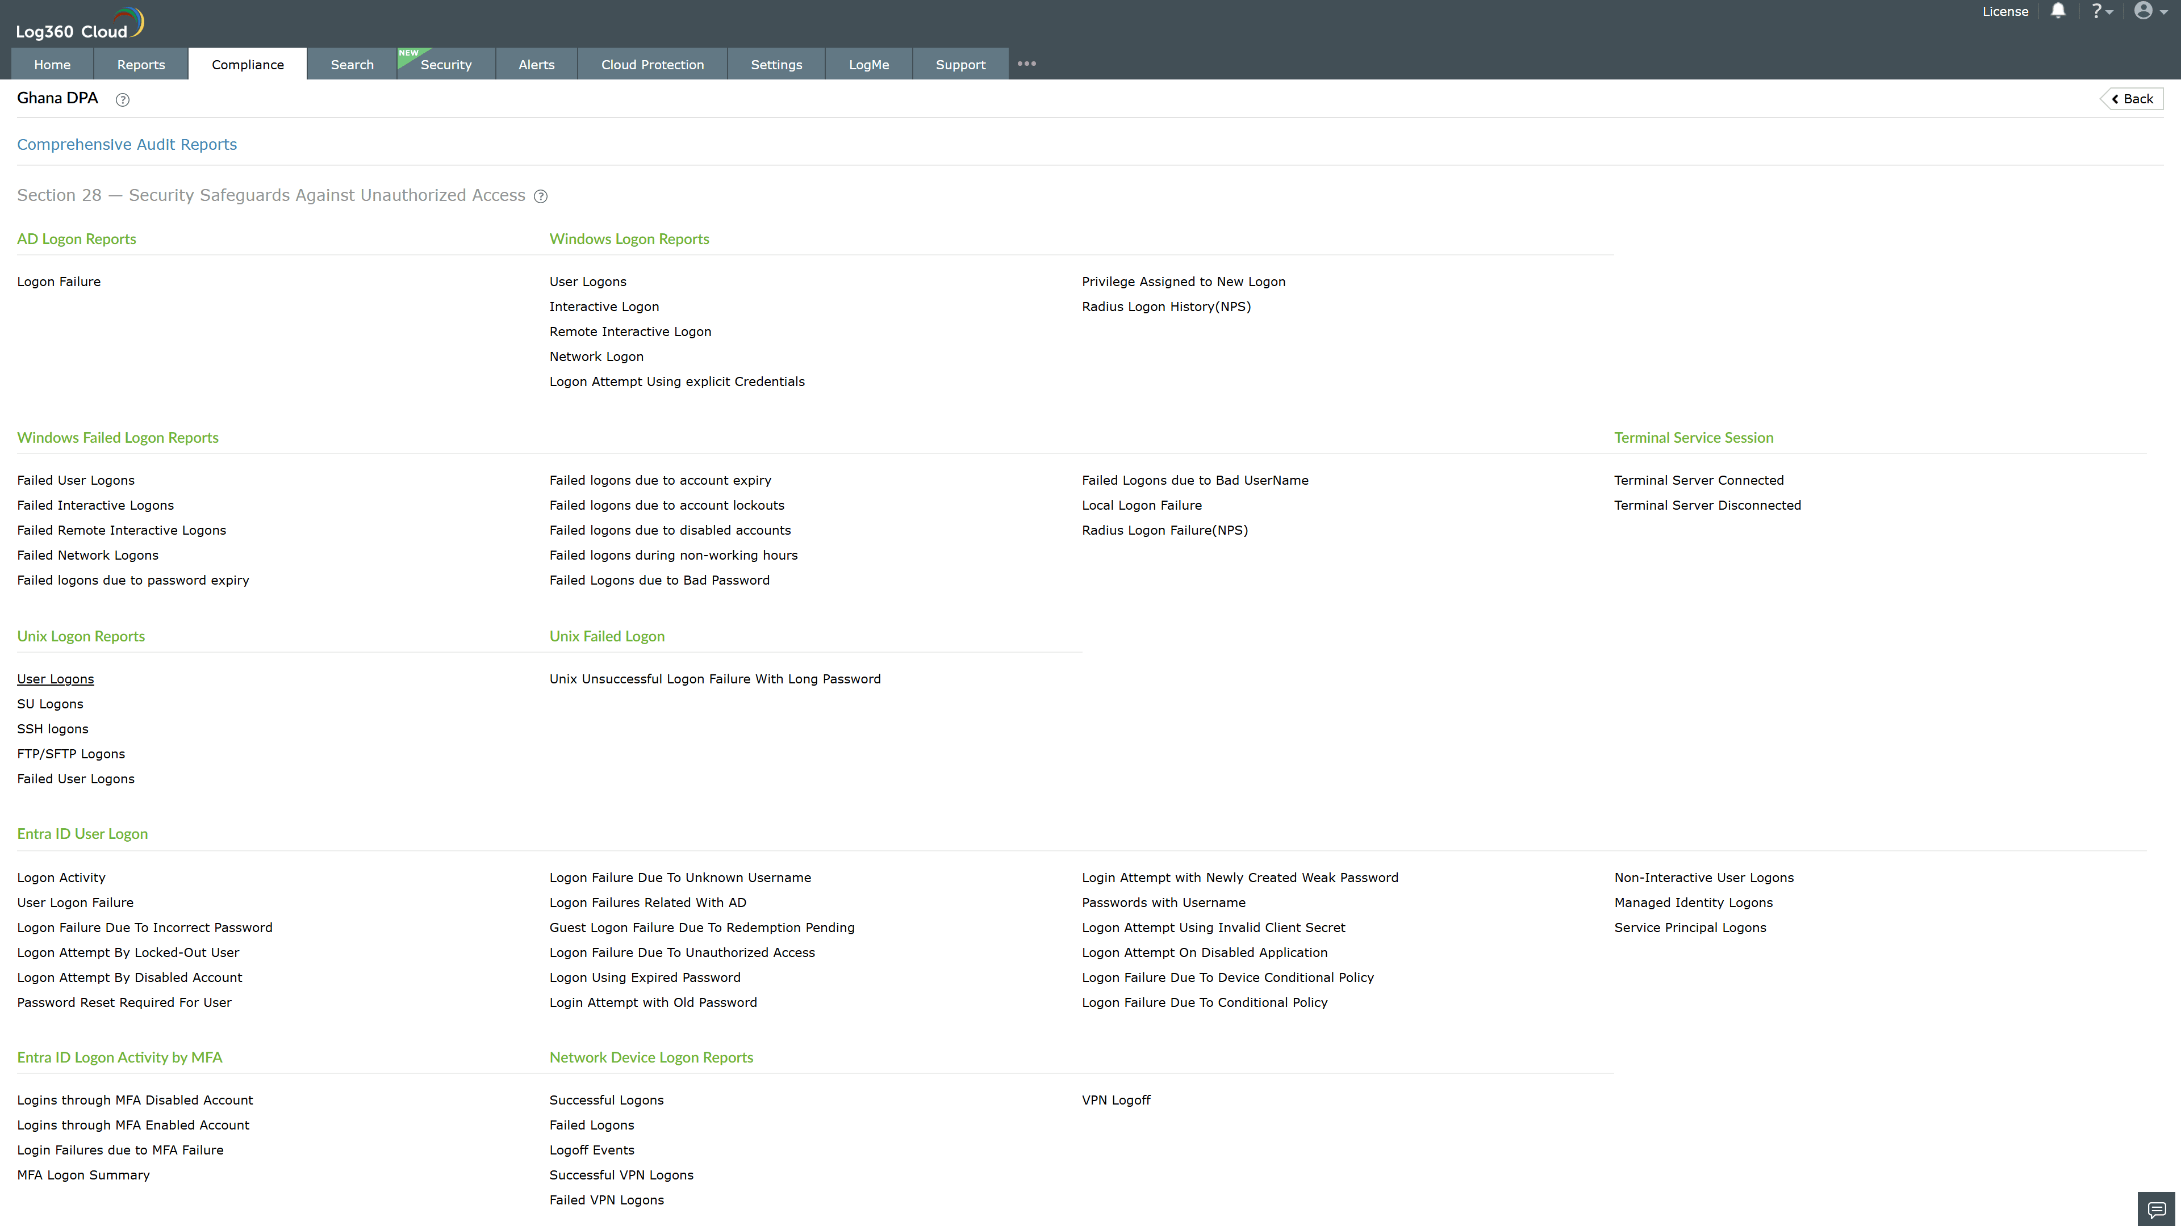
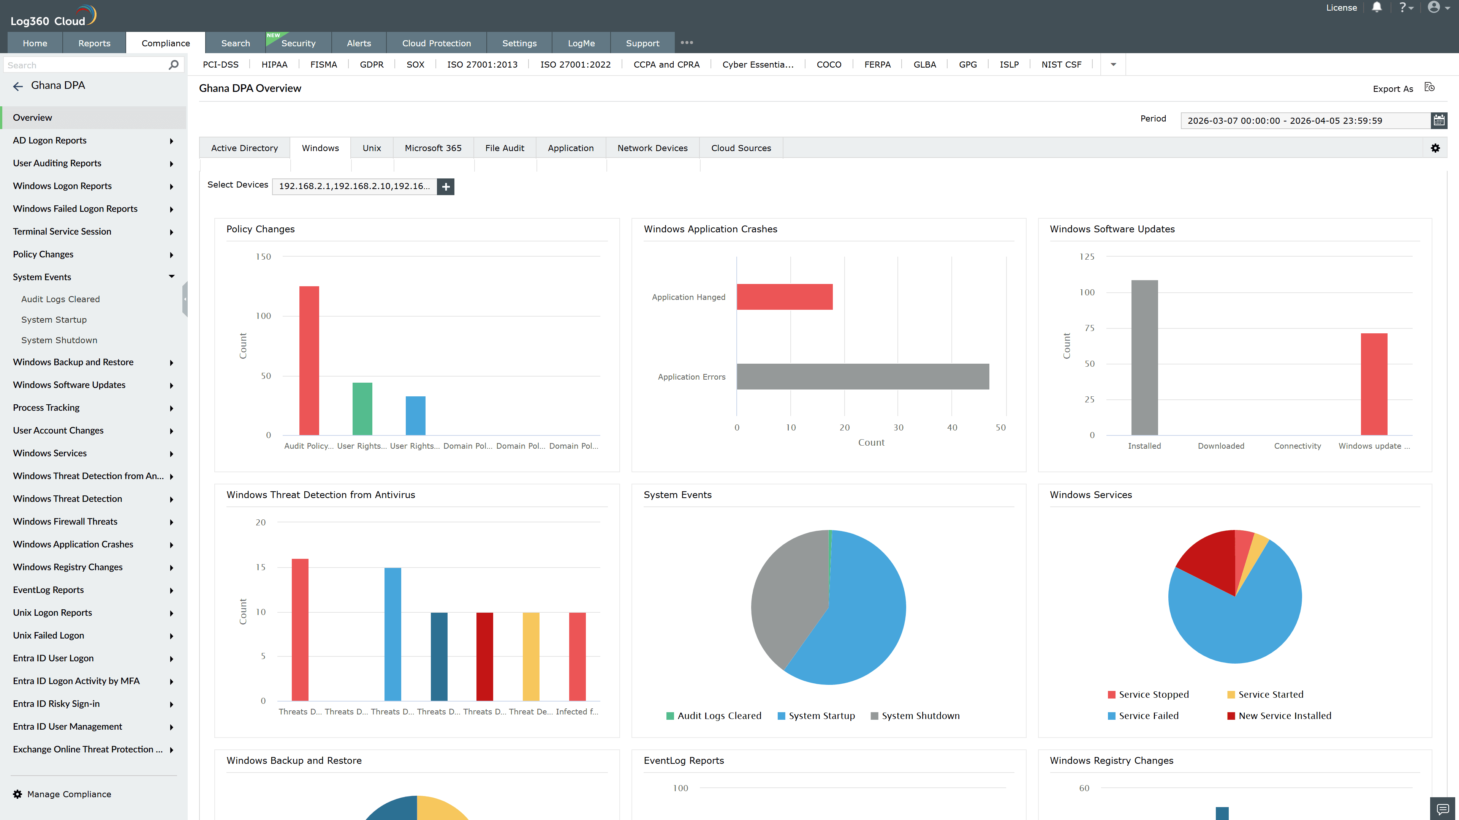
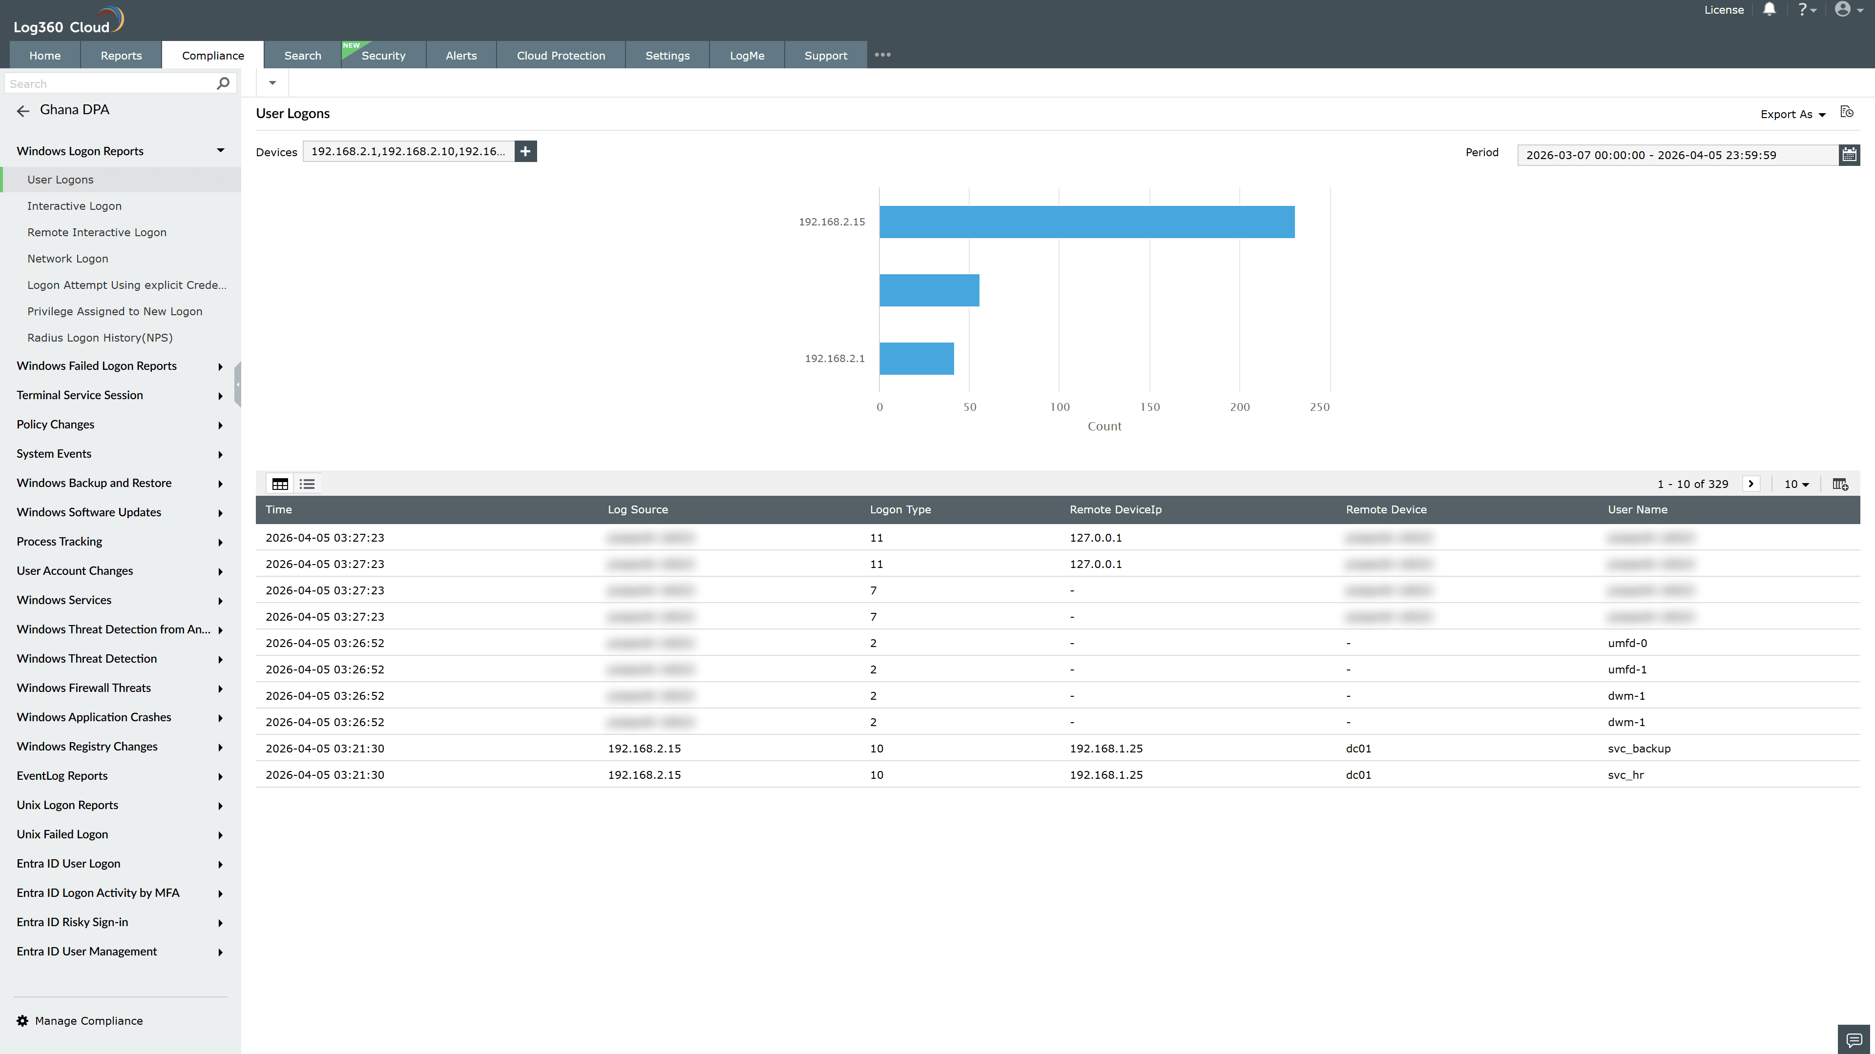
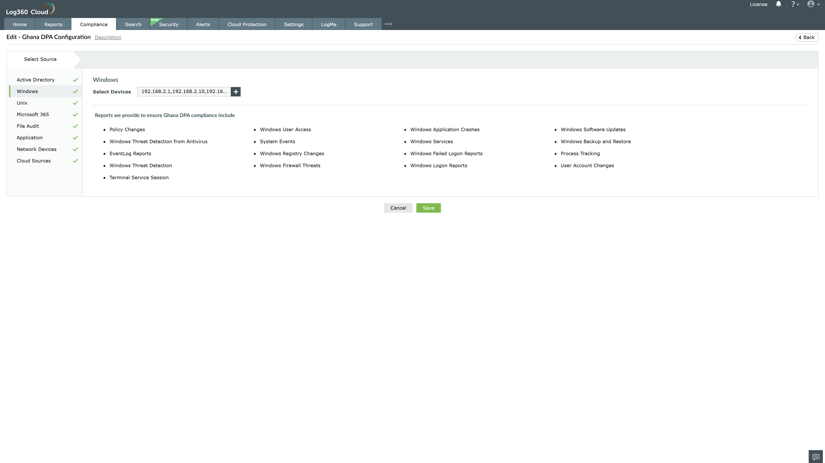
Valid Submission : Yes
Supported Editions : Free, Basic, Standard, Professional, MSSP
Help Document : https://www.manageengine.com/log-management/help/integrations/compliance-extensions.html
Help Video : Not provided
Tags : Log360, Compliance, Privacy monitoring, Data privacy, Regulatory compliance
Supported DCs : US, IN, JP, CA, AU, UK and EU
Privacy Policy:
Terms of Service:
Release Notes:
Predefined reports for the Ghana DPA.

